A
MINI PROJECT REPORT ON
Online Food Processing System

SUBMITTED TO SAVITRIBAI PHULE PUNE UNIVERSITY, PUNE
IN PARTIAL FULFILLMENT OF THE REQUIREMENTS FOR THE AWARD OF DEGREE OF

BACHELOR OF TECHNOLOGY (B.TECH)

(Artificial Intelligence & Machine Learning)
BY
Mayuri Dhammaratna Raut 32258
Arya Mahendra Jadhav 32271
Swara Nitin Rase 32274
Shrutika Sharad Kute 32275

Under The Guidance Of

Mrs. MAYURI FEGADE



Department of Artificial Intelligence - Data Science and Machine Learning

Dr. D.Y. Patil College of Engineering & Innovation
Varale – Talegaon, Pune – 410507

SAVITRIBAI PHULE PUNE UNIVERSITY, PUNE

Academic Year: 2026 – 2027

Department of Artificial Intelligence - Data Science and Machine Learning

CERTIFICATE

This is to certify that the Mini Project entitled
“Online Food Processing System”
Mayuri Dhammaratna Raut 32258
Arya Mahendra Jadhav 32271
Swara Nitin Rase 32274
Shrutika Sharad Kute 32275

is a bonafide work carried out by them under the guidance of Mrs. Mayuri Fegade, in partial fulfillment of the requirements of Savitribai Phule Pune University, Pune for the award of the degree of Bachelor of Technology in Artificial Intelligence and Machine Learning.

Mrs. Mayuri Fegade Dr. Dipannita Mondal Guide Head- AI- DS & ML

Dr. Suresh Mali Director

Signature of Internal Examiner Signature of External Examiner
ACKNOWLEDGENT

It is our pleasure to acknowledge sense of gratitude to all those who helped us in completion of Mini project. I am highly indebted to Mrs. Mayuri Fegade for their guidance and constant supervision as well as for providing necessary information regarding the internship & also for their support. I would like to express my gratitude towards Head of Artificial Intelligence - Data Science and Machine Learning Department Dr. Dipannita Mondal for their kind co-operation and encouragement which help me for providing the required facilities. Finally, we wish to thank and appreciate to all our teachers and friends for their constructive comments, suggestions and guidance and all those directly or indirectly helped us in completing this Mini Project.

Name of the Student and Sign

Place:
Date:

1 | Chapter 1: Introduction | 7
2 | Chapter 2: Problem Statement | 8
3 | Chapter 3: Objectives | 9
4 | Chapter 4: Motivation | 10
5 | Chapter 5: Scope and Rationale of the Project | 12
6 | Chapter 6: Methodological Details | 14
7 | Chapter 7: Code | 13
8 | Chapter 8: Results | 16
9 | Chapter 9: Analysis | 22
10 | Chapter 10: Inferences | 23
11 | Chapter 11: Conclusion | 24
12 | Chapter 12: Suggestions | 25
13 | Chapter 13: Acknowledgments | 26
14 | Chapter 14: List of References | 27
Contents

Chapter 1: Introduction

The purpose of this mini project is to develop an Online Food Processing System that efficiently manages incoming customer orders using a suitable data structure. The system focuses on maintaining the correct order sequence, tracking food preparation status, and displaying completed orders. Through practical implementation, the project will:
- Demonstrate how customers can place food orders through the system.
- Implement a Queue data structure to process orders in the order they are received.
- Track order preparation through different stages, such as Pending, Preparing, and Completed.
- Display completed orders and maintain proper order records.
- Improve order management efficiency, reduce confusion, and minimize manual errors.
Background: With the growth of online food delivery services, restaurants and food businesses receive multiple orders simultaneously. Managing these orders manually can lead to delays, incorrect order sequences, and difficulties in tracking preparation progress. A computerized order management system helps organize these operations systematically.
Technical Primer: The project uses the Queue data structure, which follows the FIFO (First In, First Out) principle. This means that the order received first is processed first. Each order contains relevant information, such as an order ID, customer name, food items, and preparation status. Queue operations such as enqueue (placing an order) and dequeue (removing a processed order) help manage incoming orders efficiently.
Industry Impact: An organized food processing system can benefit restaurants, cafeterias, college canteens, and small food businesses by improving order handling, maintaining the correct processing sequence, and making order status information easier to manage. It also provides a foundation for developing more advanced systems with online payments, inventory management, and customer notifications.
Project Outcome: The project aims to develop a functional Online Food Processing System that demonstrates the practical application of data structures in real-world order management. It provides an organized and reliable way to place orders, track preparation, and display completed orders.

Chapter 2: Problem Statement
Despite the growth of online food ordering platforms, many small food businesses still manage customer orders manually, leading to several problems:
- Order Management Issues: Manual recording of orders can result in missing, duplicated, or incorrect orders.
- Incorrect Processing Sequence: Orders may not be prepared in the order they are received, causing delays and customer dissatisfaction.
- Lack of Status Tracking: Customers and staff may find it difficult to identify whether an order is pending, being prepared, or completed.
- Inefficient Record Management: Managing multiple orders simultaneously without a suitable data structure can create confusion and reduce efficiency.
This project aims to:
- Develop an Online Food Processing System to manage incoming customer orders.
- Implement a Queue data structure to process orders in the order they are received (FIFO — First In, First Out).
- Provide order placement, preparation status tracking, and order completion display.
- Improve order management efficiency, accuracy, and customer satisfaction.

Industry-Specific Challenges
- Restaurants and Food Businesses: Handling multiple orders during peak hours can lead to delays and incorrect order processing.
- Order Processing: Without a proper queue system, maintaining the correct sequence of incoming orders becomes difficult.
- Order Status Tracking: Lack of real-time status updates makes it challenging for staff to monitor pending and completed orders.
- Data Management: Manual record-keeping increases the possibility of errors and makes order retrieval difficult.

Technical Requirements
- Data Structure: Queue using the FIFO principle.
- Order Placement: Accept customer details, food items, and order IDs.
- Preparation Tracking: Update order status to Pending, Preparing, and Completed.
- Order Completion: Display completed orders and remove them from the active queue.

Chapter 3: Objectives

1. Implement Order Management:
- Develop a system to accept and record incoming customer food orders.
- Store order details such as order ID, customer name, and food items.
2. Apply Queue Data Structure:
- Implement a Queue using the FIFO (First In, First Out) principle.
- Ensure that orders are processed in the same sequence in which they are received.
3. Track Order Preparation Status:
- Provide options to update order statuses, such as Pending, Preparing, and Completed.
- Allow staff to monitor the progress of each order.
4. Manage Order Completion:
- Display completed orders with their relevant details.
- Remove completed orders from the active processing queue while maintaining proper records.
5. Evaluate System Efficiency:
- Test the system with multiple customer orders to verify the correct processing sequence.
- Handle invalid inputs and empty-queue conditions to prevent errors.
- Demonstrate how a queue data structure simplifies food order management and improves operational efficiency.
6. Practical Application:
- Develop a user-friendly system suitable for restaurants, college canteens, and small food businesses.
- Demonstrate the real-world application of data structures in managing customer orders systematically.
Expected Outcome: To develop a functional Online Food Processing System that manages incoming orders efficiently, follows the FIFO principle, tracks preparation progress, and displays completed orders in an organized manner.

Chapter 4: Motivation
The motivation for this project stems from three important challenges in modern food businesses:
1. Increasing Demand for Online Food Ordering:
- Growing Customer Expectations: Customers expect food orders to be accepted quickly, prepared on time, and delivered in the correct sequence.
- Order Management Challenges: Restaurants and college canteens may receive multiple orders simultaneously, making manual management difficult.
- Real-World Example: During peak hours, a canteen may receive several orders from students within a short period. Without a systematic process, orders can be mixed up or delayed.
- Need for Automation: A computerized system can organize orders and help staff manage food preparation more efficiently.
2. Efficient Order Processing:
- Manual Errors: Recording orders on paper can lead to missing details, duplicate entries, and incorrect food items.
- Maintaining Order Sequence: Processing orders in the order they are received helps ensure fairness and reduces confusion.
- Status Tracking: A proper system allows staff to identify whether an order is Pending, Preparing, or Completed.
- Practical Learning: This project demonstrates the application of the Queue data structure and the FIFO (First In, First Out) principle to solve a real-world problem.

3. Educational and Technical Motivation:
- Application of Data Structures: The project connects theoretical concepts of queues with a practical food order management application.
- Improved Efficiency: Organizing incoming orders reduces confusion and makes order processing easier to monitor.
- Scope for Future Development: The system can be extended with online payments, inventory management, customer notifications, and order history.
- Hands-On Experience: Developing this project helps students improve their programming, problem-solving, and software development skills.
This project aims to demonstrate how a simple yet effective Queue-based system can improve food order management. It bridges the gap between theoretical learning and practical implementation by providing an organized method for placing orders, tracking preparation, and displaying completed orders.

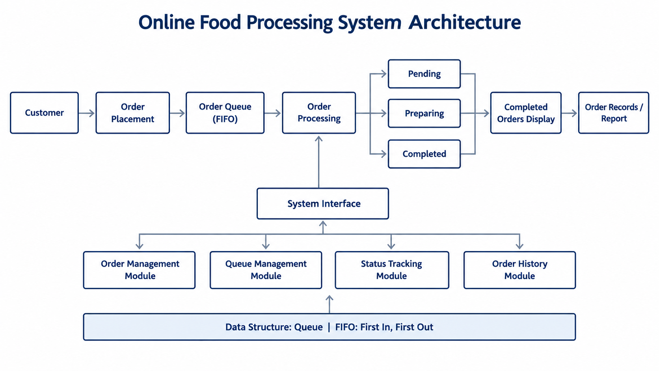
  - System Architecture:

Image Description:
This image illustrates the architecture of the Online Food Processing System, starting with customer order placement and the storage of incoming orders in a Queue data structure. It demonstrates FIFO (First In, First Out) order processing, followed by preparation status tracking through Pending, Preparing, and Completed stages. The system then displays completed orders and maintains order records and reports. The architecture also includes Order Management, Queue Management, Status Tracking, and Order History modules to ensure efficient, organized, and reliable food order processing.

Chapter 5: Scope and Rationale of the Project

Scope:
- Technical Boundaries:
- Focuses on managing customer food orders using the Queue data structure and the FIFO (First In, First Out) principle.
- Includes order placement, order processing, preparation status tracking, and completed order display.
- Maintains the correct processing sequence so that orders are handled in the order they are received.
- Practical Constraints:
  - The system focuses on basic food order management and queue operations.
  - Online payments, delivery tracking, inventory management, and real-time customer notifications are outside the current scope.
  - The system is intended for demonstration and small-scale use in restaurants or college canteens.

Rationale:
1. Hands-On Learning:
- Demonstrates practical use of enqueue, dequeue, and queue traversal operations.
- Helps students understand how FIFO maintains the correct order of incoming food orders.
2. Efficient Order Processing:
- Reduces manual errors by recording customer and food order details systematically.
- Enables staff to monitor order status and distinguish between pending, preparing, and completed orders.
3. Reliable System Functions:
- Generates order IDs to identify individual orders.
- Validates inputs and handles empty-queue conditions to avoid processing errors.
- Maintains a completed order list for reviewing previously processed orders.

4. Real-World Application:
- Provides a basic order management solution for restaurants, college canteens, and small food businesses.
- Can be extended in the future with payment integration, inventory tracking, delivery management, and customer notifications.

Chapter 6: Methodological Details
The project was implemented using Python as a menu-driven console application. It uses the deque data structure to manage incoming customer orders according to the FIFO (First In, First Out) principle. The project was executed in the following phases:
1. System Development
- Technology Used: Python programming language.
- Libraries Used: collections.deque for queue management and itertools.count for generating sequential order IDs.
- Features:
  - Accept customer names, food items, and quantities.
  - Generate a unique sequential ID for each valid order.
  - Maintain separate collections for active and completed orders.
2. Queue Implementation
- Data Structure Used: Double-ended queue (deque).
- Working Principle: FIFO (First In, First Out).
- Implementation:
  - The orders deque stores active orders in their arrival sequence.
  - The append() method adds new orders to the end of the queue.
  - The popleft() method removes the oldest order when it is completed.
  - This ensures that the oldest active order is processed first.
3. Order Placement and Input Validation
- The place_order() function accepts the customer's name, food item, and quantity.
- It checks that the customer name and food item are not empty and that the quantity is a positive whole number.
- Each valid order receives a unique ID and an initial status of Pending.
- The order is added to the active queue, and a confirmation message is displayed.
- Invalid inputs are rejected with an appropriate error message.
4. Order Preparation and Completion
- The mark_preparing() function updates the status of the oldest active order to Preparing.
- The complete_order() function removes the oldest order from the active queue using popleft().
- The completed order's status is changed to Completed, and the order is transferred to the completed_orders list.
- Both functions check whether active orders are available before performing their operations.
5. Order Display and Menu Management
- The display_orders() function displays active orders from oldest to newest, including their IDs, customer names, food items, quantities, and statuses.
- It also displays completed orders separately.
- The main() function provides a menu with five options: Place Order, Mark as Preparing, Complete Order, Display Orders, and Exit.
- The program continues running until the user selects the Exit option.
6. System Testing and Validation
- Test order placement with valid and invalid customer details and quantities.
- Verify that order IDs are generated sequentially.
- Place multiple orders and confirm that the oldest order is processed first.
- Verify status changes from Pending to Preparing and then to Completed.
- Check that completed orders are removed from the active queue and displayed in the completed orders list.
- Test empty-queue conditions and invalid menu choices to ensure appropriate messages are displayed.
The project implements a functional, menu-driven Online Food Processing System in Python. It demonstrates the practical application of the FIFO queue principle for placing orders, tracking preparation status, completing orders, and maintaining separate records of active and completed orders.

Chapter 7: Code

from collections import deque
from itertools import count

orders = deque()
completed_orders = []
order_ids = count(1)

def place_order():
customer = input('Customer name: ').strip()
food = input('Food item: ').strip()
try:
quantity = int(input('Quantity: '))
except ValueError:
print('Invalid quantity. Enter a whole number.'); return
if not customer or not food or quantity < 1:
print('Invalid input. Name and food are required; quantity must be at least 1.'); return
order = {'id': next(order_ids), 'customer': customer, 'food': food, 'quantity': quantity, 'status': 'Pending'}
orders.append(order)
print(f"Order #{order['id']} placed successfully.")

def display_orders():
print('\n--- Active Orders (oldest first) ---')
if not orders: print('No active orders.')
for o in orders: print(f"#{o['id']} | {o['customer']} | {o['food']} | Qty: {o['quantity']} | {o['status']}")
print('\n--- Completed Orders ---')
if not completed_orders: print('No completed orders.')
for o in completed_orders: print(f"#{o['id']} | {o['customer']} | {o['food']} | Qty: {o['quantity']} | {o['status']}")

def mark_preparing():
if not orders: print('No orders are waiting.'); return
orders[0]['status'] = 'Preparing'
print(f"Order #{orders[0]['id']} marked as Preparing.")

def complete_order():
if not orders: print('No orders are waiting.'); return
order = orders.popleft()
order['status'] = 'Completed'; completed_orders.append(order)
print(f"Order #{order['id']} completed.")

def main():
while True:
print('\n===== ONLINE FOOD PROCESSING SYSTEM =====')
print('1. Place order\n2. Mark oldest order as Preparing\n3. Complete oldest order\n4. Display active and completed orders\n5. Exit')
choice = input('Enter choice (1-5): ').strip()
if choice == '1': place_order()
elif choice == '2': mark_preparing()
elif choice == '3': complete_order()
elif choice == '4': display_orders()
elif choice == '5': print('Thank you. Exiting Food Processing System.'); break
else: print('Invalid choice. Please enter a number from 1 to 5.')

if __name__ == '__main__': main()

Chapter 8: Results

Aspect | Basic Implementation | Improved System / Expected Enhancement
Order Management | Orders managed manually or without a queue | Orders stored using Python's deque
Order Processing | Order sequence may be inconsistent | FIFO: oldest order processed first
Order Identification | Orders may be difficult to identify | Sequential, unique order IDs
Order Status | Status may not be tracked systematically | Pending, Preparing, and Completed
Order Completion | Completed orders may be mixed with active orders | Completed orders stored separately
Input Validation | Invalid details may be accepted | Empty names, empty food items, and invalid quantities are rejected
Active Order Display | Difficult to monitor pending orders | Active orders displayed from oldest to newest
Completed Order Display | Previous orders may not be readily available | Completed orders displayed separately
Empty Queue Handling | Processing may cause errors or confusion | Informative message displayed when no active orders exist
Order Records | Manual record-keeping | Active and completed orders maintained in separate collections

Key Observations
- The deque data structure ensures that orders are processed according to the FIFO principle.
- Sequential order IDs make individual orders easier to identify.
- Order status tracking helps distinguish between pending, preparing, and completed orders.
- Separate collections for active and completed orders improve record organization.
- Input validation and empty-queue checks help prevent common runtime errors.
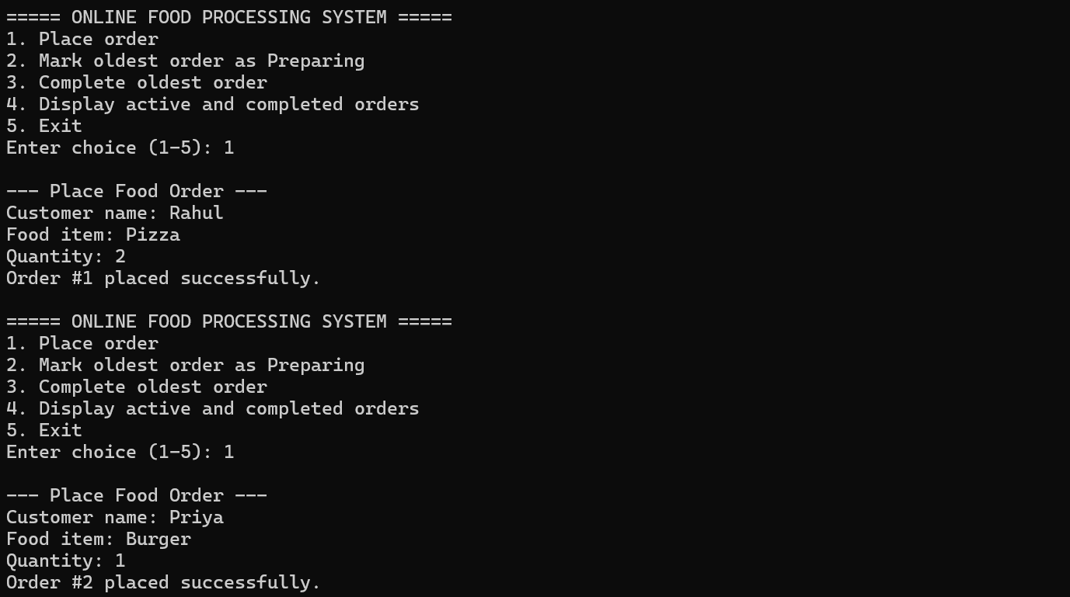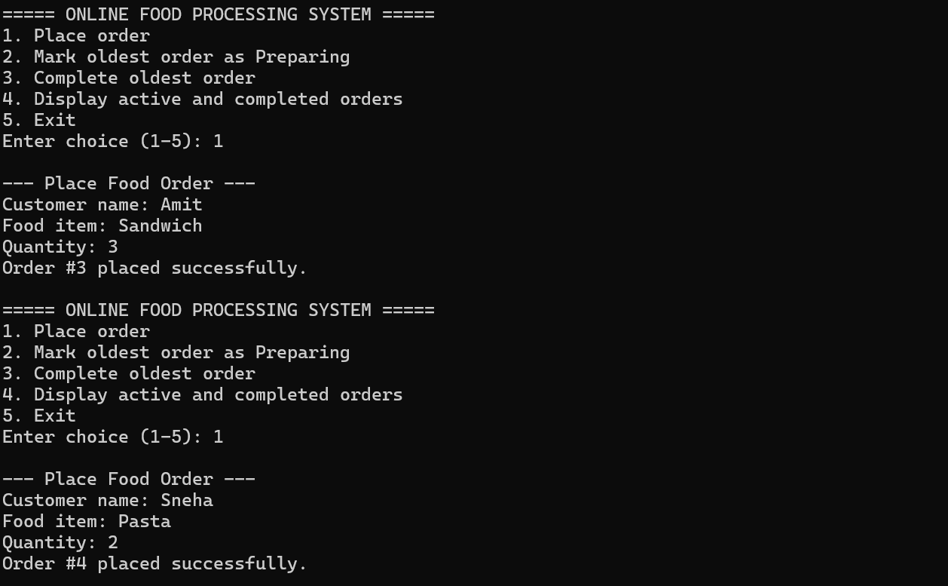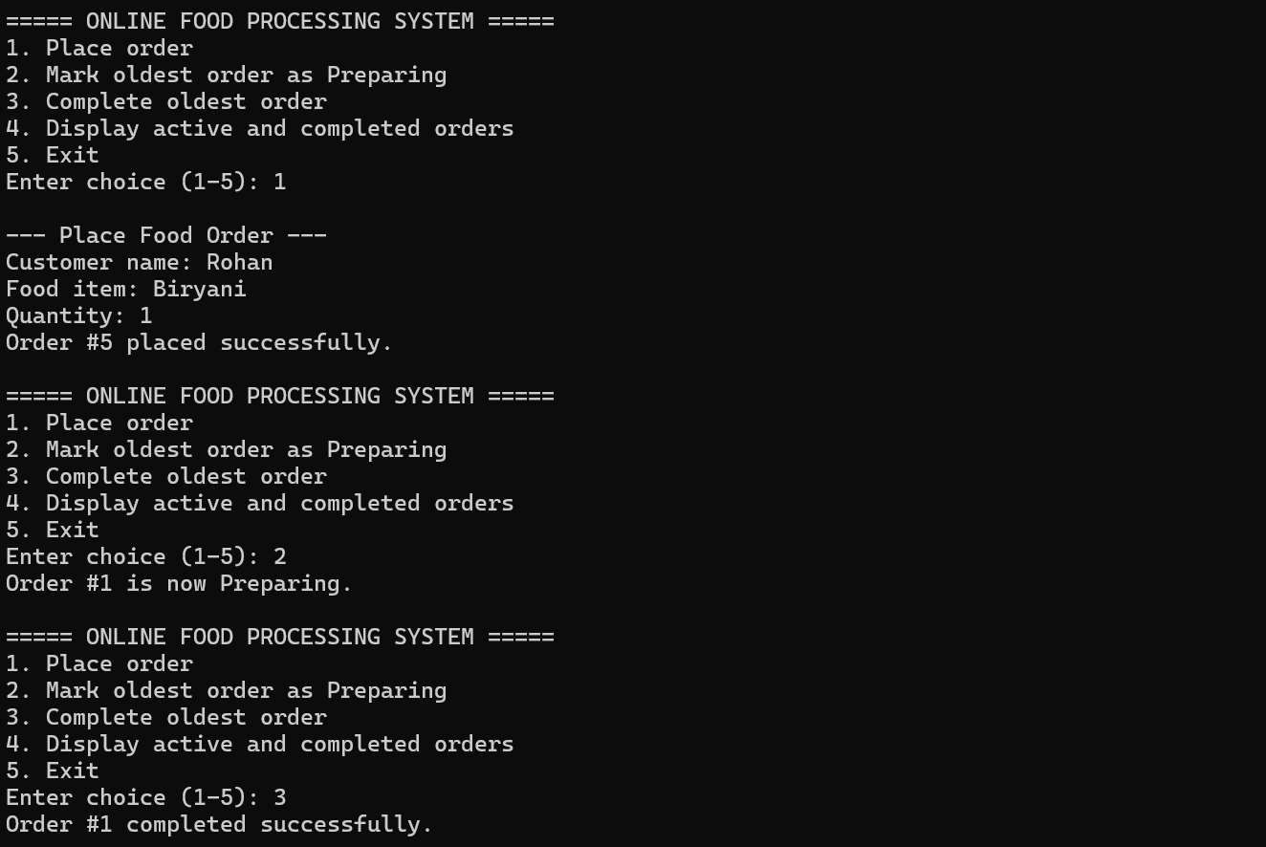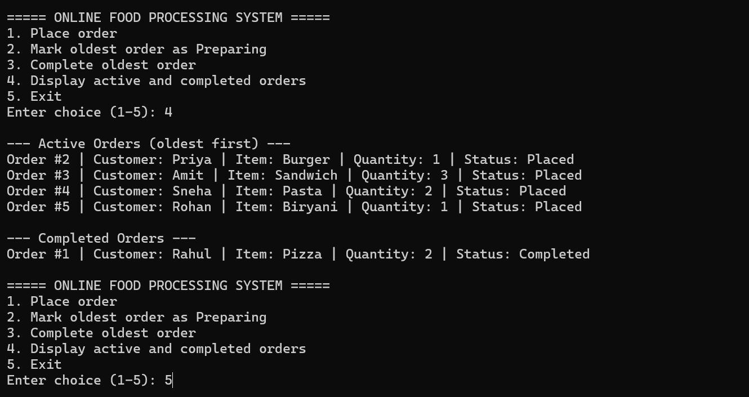

Chapter 9: Analysis

Key Findings
- Queue-Based Order Management: The deque data structure efficiently maintains incoming orders according to the FIFO (First In, First Out) principle.
- Order Status Tracking: The system tracks orders through three statuses: Pending, Preparing, and Completed.
- Order Identification: Sequential order IDs help identify and manage individual customer orders.
- Input Validation: The program rejects empty customer names, empty food item names, and invalid quantities, ensuring that only valid orders are accepted.
- Order Organization: Active orders and completed orders are stored separately, making order monitoring and record display easier.
- System Functionality: The menu-driven interface allows users to place orders, update preparation status, complete orders, display order records, and exit the application.

Limitations
- The system operates through a console interface and does not provide a graphical user interface.
- Order records are stored in memory and are lost when the program terminates.
- The program does not include online payment processing, inventory management, or delivery tracking.
- The system does not use a database or support multiple users simultaneously.
- The program does not prevent an order from being completed while its status is still Pending.

Chapter 10: Inferences

- Importance of Data Structures: The project demonstrates how a queue simplifies order management by ensuring that the oldest active order is processed first.
- Efficient Processing: Using append() and popleft() makes adding and removing orders straightforward and efficient.
- Improved Organization: Maintaining separate collections for active and completed orders makes it easier to monitor the progress of food preparation.
- Input Reliability: Input validation helps prevent incorrect order entries and improves the reliability of the application.
- Practical Application: The system demonstrates how programming concepts can solve everyday problems in restaurants, college canteens, and small food businesses.
- Scope for Improvement: Adding persistent storage, a graphical interface, and stronger order-status controls could make the system more suitable for practical deployment.

Chapter 11: Conclusion

This project successfully demonstrates the development of a Python-based Online Food Processing System using the Queue data structure.
The system provides the following functionalities:
- Accepts customer details and food orders.
- Generates sequential order IDs.
- Processes orders according to the FIFO principle.
- Tracks order statuses as Pending, Preparing, and Completed.
- Displays active and completed orders separately.
- Validates inputs and handles empty-queue conditions.
Critical Takeaway: The project demonstrates that a queue is an appropriate data structure for managing food orders in the order they are received. It connects theoretical knowledge of data structures with a practical order management application.

Future Enhancements
- Develop a graphical user interface for easier operation.
- Integrate a database to preserve order records after program termination.
- Add customer order history and search functionality.
- Introduce inventory management and stock availability checks.
- Add online payment integration and order notifications.
- Implement stricter status validation so that only orders marked Preparing can be completed.

Chapter 12: Suggestions

1. For Developers:
- Use a database such as SQLite or MySQL to store order information permanently.
- Improve input validation and error handling.
- Prevent invalid status transitions and accidental duplicate operations.
- Develop a graphical interface to improve usability.
- Add automated tests to verify queue operations and order processing.
2. For Restaurants and Food Businesses:
- Use digital order management to reduce dependence on manual records.
- Train staff to update order statuses correctly.
- Review active and completed orders regularly.
- Consider integrating inventory management to monitor food availability.
- Introduce customer notifications to communicate order progress.
3. For Future Project Development:
- Add separate interfaces for customers and kitchen staff.
- Implement order searching and filtering by order ID or status.
- Maintain order history and generate daily order reports.
- Extend the system to support multiple food items in a single order.
- Evaluate system performance with different numbers of incoming orders.

Chapter 13: Acknowledgments

I sincerely thank Dr. Dipannita Mondal, HOD of AI & DS, for her guidance, and Ms. Mayuri Fegade for her expert mentorship in web security. My gratitude extends to our department for providing Kali Linux and other essential tools.
I deeply appreciate my project team – Harshad Kawade, Om Kalyankar, and Rajesh Shinare for their dedication in developing the demo website, executing attack simulations, and implementing HTTPS security measures. Our collaborative efforts in debugging and testing were crucial to this project's success.
Special thanks to the open-source community for tools like Let's Encrypt and OWASP resources that made our practical demonstrations possible.

Chapter 14: List of References

- Queue Data Structure (FIFO) —
https://www.geeksforgeeks.org/queue-data-structure/⁠
- Python Queue Documentation — https://docs.python.org/3/library/queue.html⁠
- Python deque Documentation — https://docs.python.org/3/library/collections.html#collections.deque⁠
- Python Classes and Objects — https://docs.python.org/3/tutorial/classes.html⁠

